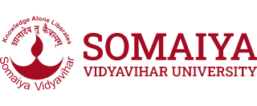

|  |  |  |
| --- | --- | --- |
| **Sem: NOV-2024**  **Maximum Marks: 50 Examination: End Exam Date: Duration: 2.5hrs** | | |
| **Programme code:**  **Programme:** MBA for working executive  (program code-18) | **Class:** FY | **Semester: 3**  **Batch- (Regular/ATKT)** |
| **College:**  **K. J. Somaiya Institute of Management** | **Name of the department/Section/Center:** | |
| **Course Code: 117P18C338** | **Name of the Course:  Strategic Innovation** | |
| **Instructions: Answer any five questions. All questions carry equal marks** | | |

|  |  |  |
| --- | --- | --- |
| **Question No.** |  | **Max.**  **Marks** |
| 1 | Explain five barriers to innovation in an organization. | 10 |
| 2 | Analyse the difference between exploratory & exploitative innovation & provide examples of two innovations that are exploratory & two that are exploitative. | 10 |
| 3 | What is your understanding of disruptive innovation? | 10 |
| 4 | List five initiatives that an organization can adopt do to ensure that innovation is strategic. | 10 |
| 5 | Discuss two examples of product innovation & two examples of service innovations. Describe what was being done earlier & what is the current innovation | 10 |
| 6 | Explain Design thinking with an example. | 10 |