**Introduction**

While watching someone pick up trash from the road, Michelle Clarks recalled the old adage that trash for one person could be treasure for another. Online research revealed a number of companies producing upcycled designer bags made from plastic, but most of them catered to high-end consumers. Soon Clarks founded Lost Treasures, an accessory company that manufactures and sells bags, belts, and jewelry from various types of “trash” such as used tires, metals and plastics, milk cartons, fabrics, and used wood.

Lost Treasures produces its handmade products locally and offers them at accessible prices. Three years after its founding, Lost Treasures is on the brink of becoming a medium-sized company, with an offer from a major retail chain to sell its products. The current marketing team consists of a marketing manager, Richard Scott, and a newbie in the company, Daniel Johnson, hired for his expertise in social media marketing.

For online campaigns, the marketing department has created Instagram and Facebook accounts showcasing the company’s latest creations through pictures and story functions. With the help of these functions, Lost Treasures advertised products and informed followers of upcoming sales. Carousel ads on both platforms highlighted features of Lost Treasures’ accessories and showed the process behind the manufacturing of its products. Users can swipe through these ads to view additional pictures and videos linked to Lost Treasures’ website. However, Clarks has recognized that the company channels and advertising are not generating the reach she desires, and she is considering partnering with influencers

**The Struggle Is Real: Choosing the Right Influencer**

The message Lost Treasures wants to convey must target the right platform and audience. Although influencers use different video formats such as tutorials, lookbooks, product reviews, hauls, and hacks, not all formats will work for Lost Treasures (Schwemmer & Ziewiecki, 2018). What Lost Treasures will need is an influencer who creates content that users will want to engage with (Meffert et al., 2015). That is, the company is hoping to gain followers who will interact more with the posts, videos, or the influencer through comments, likes, sharing, and similar actions. Johnson has prepared a portfolio consisting of basic information on three different female influencers Clarks might want to consider for her campaign.

**Mrspress**

Clare Press, aka Mrspress, began her career as a senior writer at Rolling Stone and is now a presenter on the Wardrobe Crisis podcast. She is an author and public speaker who lives for sustainable fashion, aiming to educate people around the world. Each week, she interviews interesting people—designers, creatives, change-makers—on topics concerning ethical and sustainable fashion. Her commitment to sustainability has not gone unappreciated: she was named one of the Australian Financial Review’s 100 Women of Influence in 2019, and she won the Green Globe Sustainability Champion Award. Lost Treasures could benefit from working with her as she is the fashion industry’s go-to journalist concerning sustainability and ethics (Wardrobe Crisis, 2020). Next to her website, she is also very active on [Instagram](https://www.instagram.com/mrspress/), where she has generated over 39.5k followers. On Instagram, Clare often posts clothing items she has purchased in thrift shops in her story and gives her followers insight into her personal life as a sustainable fashionista (see Figures 1 and 2).Figure 1. Instagram Post on Vintage Clothes by Mrspress

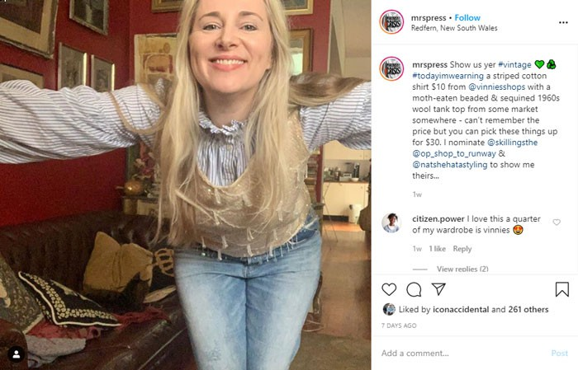

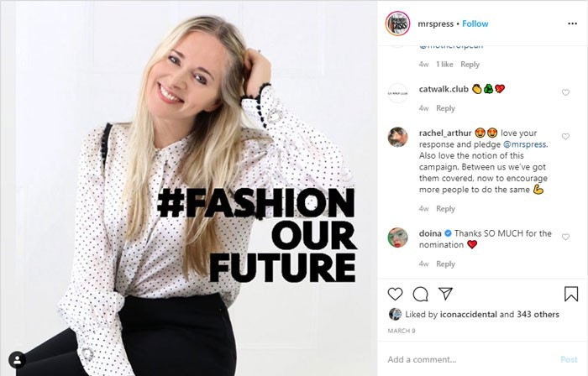Figure 2. Instagram Post on Sustainable Fashion by Mrspress

**Plasticfreemermaid**

Plasticfreemermaid, born Kate Nelson, is an ethical influencer, environmentalist, activist, yoga teacher, writer, and—most importantly—ocean lover. What makes her a potential influencer for Lost Treasures is the fact that she has been living a disposable plastic-free life for ten years now. Kate’s Instagram profile reflects a deep link to nature and love of the environment through pictures of oceans and plastic-related pollution images, such as plastic bottles being swept up by the ocean (see Figures 3 and 4). Kate founded a non-profit called [Save](http://www.savethemermaids.org/) [the Mermaids](http://www.savethemermaids.org/), which educates society about human-sourced ocean pollution (IQuitPlastics, 2020). Moreover, Kate raises social awareness around environmental issues through her social media platforms: [Instagram](https://www.instagram.com/plasticfreemermaid/) (101k followers), [Facebook](https://www.facebook.com/plasticfreemermaid) (5.6k followers), and [YouTube](https://www.youtube.com/channel/UCy2CO9_gCLCzEzPEAlROyvQ) (2.36k followers). Most recently, she is increasing her knowledge of sustainable fashion and is looking into different areas that show gaps in sustainable fashion.

Figure 3. Instagram Post on Ocean Plastic Pollution by Plasticfreemermaid

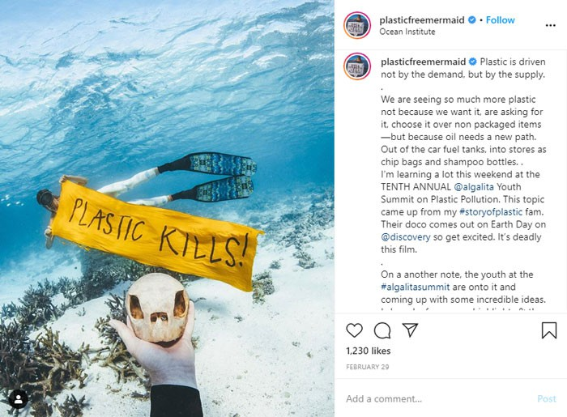

Figure 4. Instagram Post on How to Avoid Plastic by Plasticfreemermaid

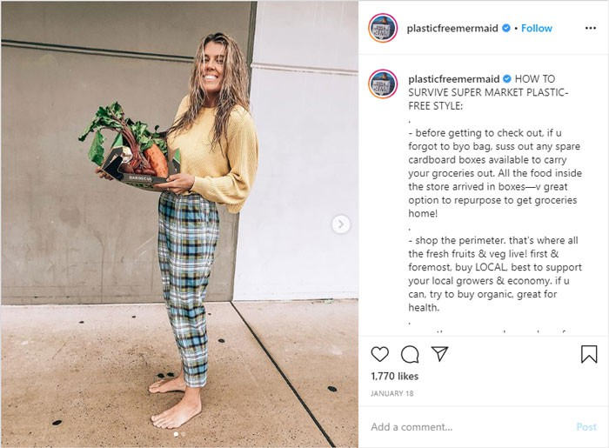

**PickUpLimes**

Sadia Badiei is a Canadian foodie and dietetics graduate, currently living in the Netherlands. The positive vibes she projects in her YouTube videos and Instagram pictures are what help her to stand out. The number of her [YouTube](https://www.youtube.com/channel/UCq2E1mIwUKMWzCA4liA_XGQ) followers (3.13m) reflect the power of her positivity. Sadia lives a vibrant life and gets her energy from plant-based foods, which is why she created PickUpLimes as a medium to share appealing and nutritious vegan recipes. Moreover, Sadia is interested in topics such as minimalism and healthiness. It is important to Sadia to create a community of people who share similar values and interests (PickUpLimes, 2020). What makes Sadia most interesting for Lost Treasures is her many social media channels and her immense follower reach: next to YouTube, the vegan influencer is also active on [Facebook](https://www.facebook.com/pickuplimes) (81.6k followers), [Pinterest](https://www.pinterest.com/sadiabadiei/) (139.6k followers) and [Instagram](https://www.instagram.com/pickuplimes/) (686k followers). Through these channels, Sadia shares DIY vegan recipes (see Figure 5) but she is starting to present new topics such as plastic-free tips and tricks or hacks—that is, she demonstrates cunning techniques to accomplish daily tasks more easily and without harming the environment. For example, Sadia films healthy eating hacks that come with a printable guide forher followers. As an influencer who finds it essential that her content provides value to her viewers, she could inform on environmental topics and place Lost Treasures’ products authentically.

# A screenshot shows a post on Instagram by Sadia Badiei on her account @pickuplimes about her peanut veggie noodle stir fry recipe.Figure 5. Example Vegan Recipe From PickUpLimes

Source: Sage Business Cases