**Deep Dive into Xiaomi’s Strategy to Dominate the Connected Home**

[Luna Yue Yuan](https://medium.com/@yuany44?source=post_page-----fe21476b0b54-----------------------------------)

[Luna Yue Yuan](https://medium.com/@yuany44?source=post_page-----fe21476b0b54-----------------------------------)

[Jul 10, 2017·25 min read](https://medium.com/@yuany44/deep-dive-into-xiaomis-strategy-to-dominate-the-connected-home-fe21476b0b54?source=post_page-----fe21476b0b54-----------------------------------)

**Xiaomi’s Corporate Strategy**

Although Xiaomi is first and foremast in the phone business, its ambition goes far beyond. The CEO Lei Jun considers the mobile phone to be a converged system of “software + hardware + internet”, instead of a simple device for communication. The same “internet thinking” could be applied to many other smart devices. Xiaomi’s aggressive entry into the phone market with competitive pricing and its quick expansion into other product categories are not by accident, but rather, as part of the well-thought-out plan.

In Lei Jun’s vision, there are three layers of product offerings in Xiaomi’s ecosystem **[Exhibit 4].** At its core, are its well-established products of smartphones, smart TV, TV set-top boxes (HRD streamer), and routers. As elaborated in the previous section, Xiaomi is a late entry into the competitive smartphone market in China, but has gained substantial market share through its innovative business model. However, China’s smartphone market is quickly getting saturated: IDC estimates it to grow between 1% and 2% in 2016 while not long ago, the market was doubling every year.[[7]](https://medium.com/@yuany44/deep-dive-into-xiaomis-strategy-to-dominate-the-connected-home-fe21476b0b54#_ftn1) Globally, smartphone shipments are expected to slow to 3.1% in 2016, from 10.5% in 2015 and 27.8% in 2014.[[8]](https://medium.com/@yuany44/deep-dive-into-xiaomis-strategy-to-dominate-the-connected-home-fe21476b0b54#_ftn2) Further complicating the matter is the changing consumer preference. One hypothesis behind Xiaomi’s decline is that once first-time buyers get a taste of life with a smartphone, they look upstream a bit when it’s time to buy a new device — and Xiaomi’s value proposition no longer appeals to them.[[9]](https://medium.com/@yuany44/deep-dive-into-xiaomis-strategy-to-dominate-the-connected-home-fe21476b0b54#_ftn3) On the other hand, despite Xiaomi’s strong market positions in smart TV, and TV set-up box, the profitability is low given the immaturity of the market segment and the regulatory uncertainties. Xiaomi’s Wifi router has earned №1 market position with 9 million accumulated sales since 2015 — good record but like smart TV, it’s still in an early market and its sales only represent a small segment compared to Xiaomi’s phone business of 70 million sales in 2015 alone.

[**Exhibit 4:**Xiaomi’s three layers of ecosystem]

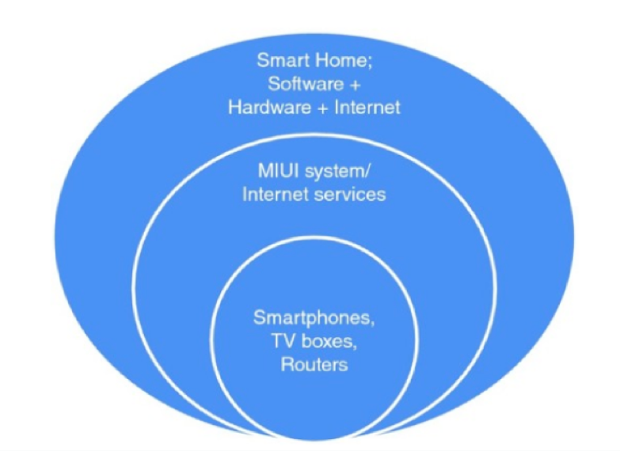

Source: Winston Ma (2016), *Book*China’s Mobile Economy: Opportunities in the Largest and Fastest Information Consumption Boom.

The next level up is the Internet services based on Xiaomi’s MIUI system that supports the hardware products. According to Lei Jun, smartphones serve as a distribution channel and not a source of profits. Selling phones is Xiaomi’s strategy to get access to users so that Xiaomi could “milk the cow” later on. As Xiaomi’s smartphone sales slowed down in growth, Lei Jun said in early 2015 that Xiaomi would make Internet services such as smartphone games and mobile finance an increasing part of its business, and expected the revenue from Internet services to triple to nearly $1 billion[[10]](https://medium.com/@yuany44/deep-dive-into-xiaomis-strategy-to-dominate-the-connected-home-fe21476b0b54#_ftn1). In June 2016, Xiaomi’s App store hit the 50 billion download mark[[11]](https://medium.com/@yuany44/deep-dive-into-xiaomis-strategy-to-dominate-the-connected-home-fe21476b0b54#_ftn2). Xiaomi’s Internet service — primarily games, but also payments and cloud storage, rose 150% to $564 million in 2015. The growth was impressive, but represented less than 5% of the company’s total revenue and far short of Xiaomi’s internal target of $1 billion.[[12]](https://medium.com/@yuany44/deep-dive-into-xiaomis-strategy-to-dominate-the-connected-home-fe21476b0b54#_ftn3)

The third layer coincides with Lei Jun’s ultimate vision for the future of Xiaomi — to become an important player in the “internet of things” and the “smart home”. A family of smart home devices will be seamlessly connected under the Xiaomi ecosystem. Despite the sharp drops in smartphone sales, Xiaomi will not take a big hit as its profit growth will be driven by sales from smart home devices. In April 2016, one of Xiaomi’s senior executives predicted the sales of smart home devices to double to $1.5 billion this year.[[13]](https://medium.com/@yuany44/deep-dive-into-xiaomis-strategy-to-dominate-the-connected-home-fe21476b0b54#_ftn1)

After analyzing the three layers of Xiaomi’s intended ecosystem in the context of changing industry landscape and Xiaomi’s sales performance in recent years, it becomes clear why Xiaomi would want to move into the space of Internet services and Smart Home. Perhaps more accurately put, Xiaomi understands where majority of values will be created along the value chain of the connected home and has prepared itself from day 1 to become an Internet service provider and a software platform that connects user-to-user, user-to-device, and device-to-device. However, this space is already filled with dominant players from both big Internet firms such as Baidu, Tencent and Alibaba, as well as established home appliance manufacturers that are looking to transform themselves such as Gree and Midea. Thus Xiaomi decided to enter the space through smartphone market to avoid direct head-on competition from big players, while effectively acquiring and locking in users by building an ecosystem integrating software and hardware around their needs. Indeed, Xiaomi has done a terrific job in engaging its users. Xiaomi’s product managers can spend half their time browsing through the company’s user forums, analyzing user feedback, picking up suggestions and quickly passing them to engineers to be incorporated as new features. [[14]](https://medium.com/@yuany44/deep-dive-into-xiaomis-strategy-to-dominate-the-connected-home-fe21476b0b54#_ftn1) As a result, the average Xiaomi user spends 7% more time in apps than iPhone consumers **[Exhibit 5]**. [[15]](https://medium.com/@yuany44/deep-dive-into-xiaomis-strategy-to-dominate-the-connected-home-fe21476b0b54#_ftn2) Given Xiaomi’s resource constraint as a startup itself, in order to meet the consumer demands once they become ready, Xiaomi needs to acquire/invest in companies that could potentially offer the products consumers are looking for in advance. What they could offer to these Mi Ecosystem Companies in return, are immediate cost reduction benefiting from Xiaomi’s global supply chain network, and sales bump-up as being associated with Xiaomi brand.

[**Exhibit 5**: Xiaomi’s mobile app store screenshots & download growth from 2014–2016 (reaching 40 billion in 2016.03)]

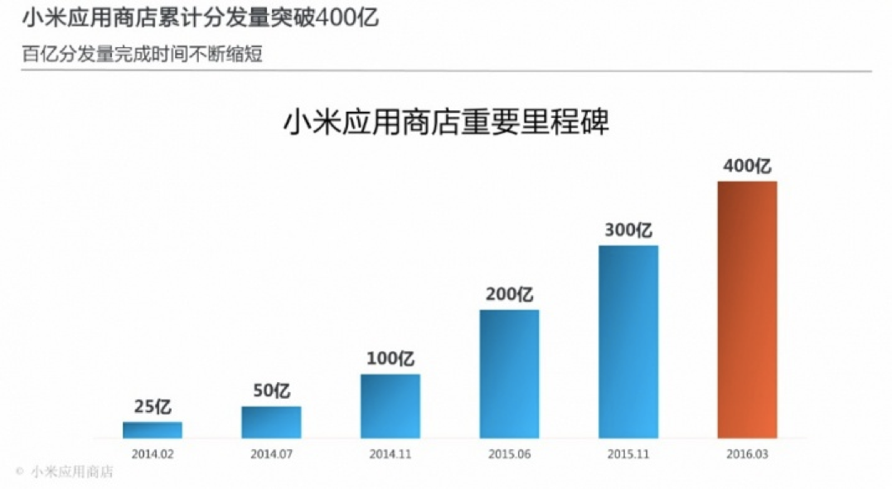

Therefore, Xiaomi’s corporate strategy could be inferred as the following:

To seize large market share, pursue high growth and profitability, and dominate the connected home by 1) growing its three layers of ecosystem simultaneously with a combination of in-house core product development and investments in smart home devices, 2) acquiring users aggressively with a large catalog of affordable and high-quality products of its own and those of its Ecosystem Companies, and 3) retaining users through active engagement and competitive internet services, in self-contained divisions that share the brand association, supply chain relationships, and distribution channels.

**IV. Assessment of Lei Jun’s Strategic Decision**

Having understood Xiaomi’s Corporate Strategy, CEO Lei Jun’s decision to invest in “100 Mi Ecosystem Companies” in 5 years can be seen as a diversification strategy for Xiaomi to quickly enter new product categories under the “Smart Home” layer. In China, technology innovations are not sustainable enough — copycats could quickly follow after a successful product. Xiaomi has to always defend its access to users who sustain the entire ecosystem, which supports Xiaomi’s direct (product sale) and indirect (revenue share from its partners, and charging consumers for cloud storage/internet services/entertainment content) monetization. Please see **Exhibit 6**for a complete illustration on Xiaomi’s monetization model. I will explain the various aspects in more details in the following “Businesses” section.

[**Exhibit 6**: Graphic illustration of Xiaomi’s monetization model]

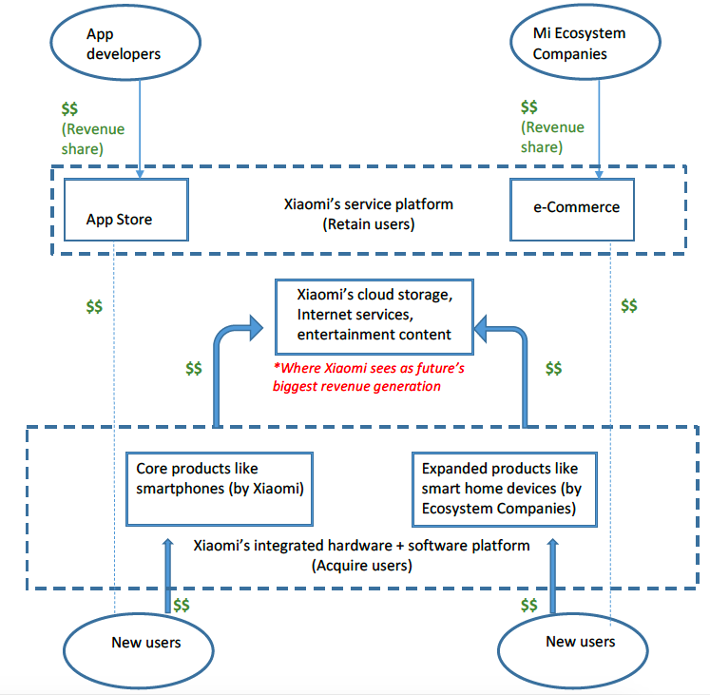

Source: author’s original creation

Therefore, the question is not whether Xiaomi should expand to new product categories — it has to, otherwise it will soon lose its power engine being stuck in a declining smartphone industry. The question is, how. Specifically, how does Xiaomi decide which products to develop internally and which to “outsource” to its Ecosystem Companies? How does Xiaomi come up with the investment criteria for the potential Ecosystem Companies? And lastly, how to implement the strategy successfully?

To further assess Lei Jun’s strategic decision to invest in 100 Mi Ecosystem Companies, and to address questions above, we will dive deeper into the synergies between Xiaomi and the potential portfolio companies through the lens of “Attractiveness Test”, “Better-off Test”, and “Ownership Test”, given the context of Xiaomi’s businesses, resources and organization structure.

**Businesses**

Though seemingly difficult to track, Xiaomi’s businesses could be seen as being expanded both vertically and horizontally **[Exhibit 7]**.

[**Exhibit 7**: Xiaomi’s business expansion]

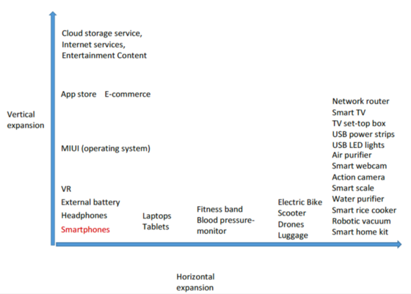

Source: author’s original creation

Along the vertical line extended from smartphones, Xiaomi offers phone accessories like headphones, external battery, and recently, Xiaomi’s Virtual Reality headsets. Xiaomi’s own operating system MIUI is integrated with its hardware. Further above is Xiaomi’s App Store, which has grown dramatically in user downloads in the past two years **[Exhibit 5]** and seen more time spent in Apps by average Chinese smartphone users than other competitors, including Apple**.**Next to it, is Xiaomi’s e-commerce platform (available in forms of a website and an app), which aggregates catalog information from product lines that expand horizontally **.** It has recently become one of the world’s top 10 largest e-retailers, right after Apple Then lastly, Xiaomi provides cloud storage service (Mi Cloud), Internet services (mobile finance and mobile games), and entertainment (through its $1bn investment to produce its own TV and video content[[16]](https://medium.com/@yuany44/deep-dive-into-xiaomis-strategy-to-dominate-the-connected-home-fe21476b0b54#_ftn1)). The businesses along the vertical expansion are owned by Xiaomi and become part of Xiaomi’s resources to entice potential app developers and Mi Ecosystem Companies. The more popular Xiaomi’s app store and e-commerce store becomes, the more powerful they become as distribution channels for Xiaomi’s partners. It is also worth noting that these businesses, when tightly integrated, become a virtuous cycle that spans user acquisition (smartphones and peripherals), user retention (MIUI, App Store, E-Commerce), and the biggest value capturing along the value chain (Cloud storage service, Internet services, and Entertainment Content).

Along the horizontal expansion, Xiaomi moves aggressively into consumer electronics, smart devices and IoT devices. This is where Xiaomi’s Ecosystem Companies add value, by bridging the knowledge gap of a new product line that Xiaomi lacks experiences in and contributing towards the variety of Xiaomi’s product offerings — which in turn, feeds into the success of Xiaomi’s e-commerce store. Lei Jun’s announcement to “invest in 100 Mi Ecosystem Companies” could accelerate this horizontal expansion. To decide which companies to approach, Xiaomi needs to apply the “*Attractiveness Test.”*

*“Attractiveness Test”*

According to a talk[[17]](https://medium.com/@yuany44/deep-dive-into-xiaomis-strategy-to-dominate-the-connected-home-fe21476b0b54#_ftn1) given by the Xiaomi’s cofounder Liu De, in early 2013, Xiaomi recognized that the time of Internet of Things (IoT) was coming, that one day all devices around us could be connected to the Internet and be controlled by phones. Xiaomi didn’t want to miss one of the biggest opportunities of our time, thus decided to catch the trend through a combination of investments and incubation of target companies in the space. That was the origin of Xiaomi’s 100 Ecosystem Companies strategy. A little research revealed that this industry is indeed attractive: Cisco predicts the global IoT market will be $14.4T by 2022[[18]](https://medium.com/@yuany44/deep-dive-into-xiaomis-strategy-to-dominate-the-connected-home-fe21476b0b54#_ftn2); BI Intelligence forecasts that there will be 34 billion devices connected to the internet by 2020, up from 10 billion in 2015. Among the connected devices, IoT devices will account for 24 billion, while traditional computing devices such as smartphones and tablets will comprise 10 billion. Lei Jun was right to focus the majority of Xiaomi’s Ecosystem Companies investments on ones making smart devices with potential to be connected. Most of these Ecosystem Companies are early-stage startups. On one hand — they are cheaper to invest; on the other — they are more flexible to and agile to adapt to the consumer needs, and are more eager to succeed in this new industry.

**Resources**

Xiaomi’s resources include the following:

- Tangible: distribution channel including its e-commerce platform and App store

- Intangible: brand, loyal fan-base, large user-base, culture, global supply chain, technology ecosystem, economies of scale, sales/marketing know-how, best practices on making consumer products with low price/performance ratio

- Capabilities: speed of product development, operational efficiency, R&D, speed of bringing product to market and scaling, industrial design

Given that Xiaomi’s users are spending more time in Apps than any other competitor, and the fact that Xiaomi could grow to the №1 market leader in Chinese smartphone industry in just three years, it is safe to say that Xiaomi’s resources provide competitive utility benefits (low cost, high quality, great internet services) to its users and pass the “Test of Current Demand”. Thanks to Xiaomi’s business model innovation, it sells smartphones in many aspects similar to phones from Apple and Samsung for less than half the price. Xiaomi’s global supply chain is managed directly by CEO Lei Jun is one of Xiaomi’s biggest competitive advantages. Xiaomi could make almost any hardware more cheaper compared to competitors’. It is hard to control an extensive supply chain and many hardware startups fail to ensure enough manufacturing capacity. However, Xiaomi is able to leverage its innovative limited flash sales to turn disadvantages into advantages. Moreover, Xiaomi coordinates its industrial design to ensure that Xiaomi’s products do not risk running into manufacturing shortage or low throughput yield. Xiaomi’s economies of scale, knowledgebase on marketing and product development, and defensible technology ecosystem are not easy to copy by competitors, leading to sustainable corporate advantage (“Test of Future Scarcity”). Xiaomi target the young people in fast-growing, nascent and immense middle class who aspire to buy products next to top brands at an affordable price. This group became Xiaomi’s large user-base that fueled its growth. Xiaomi’s brand especially appeals to a niche group of smartphone power-users who are constantly tweaking their phones for richer features and the newest experience. Xiaomi engages a lot with their power-users through forums and social media, even providing some off-site “jobs” for them such as bug reporters, beta testers etc. These power-users become enthusiastic salesmen for Xiaomi, promoting products to their friends and family for free. The large user-base and loyal fan-base are Xiaomi’s valuable resources. Lastly, as analyzed earlier, Xiaomi’s vertical expansion allows it to effectively create and capture values within its ecosystem. Its direct access and trust relationships with end customers allow it to disintermediate the channels along the value distribution chain and claim a large amount of profit sharing from the vendors (either app developers or Ecosystem Companies) on its platform, therefore passing the “Test of Appropriability”. To assess whether investing in “100 Mi Ecosystem Companies” strategy improves the competitive advantage of individual business units, we need to apply “Better-off Test”.

*“Better-off test”*

Through investments, Xiaomi adds significant values to its Ecosystem Companies through resource transfers which translate to revenue and cost synergies. Xiaomi imparts to these companies its best practices to making quality products and bringing the product to market, therefore improving the Mi Ecosystem Companies’ competitiveness. Xiaomi seems to favor Ecosystem Companies whose technology adoption lifecycle is in between adopters and the mainstream — products in this phase are best positioned to take advantage of Xiaomi’s supply chain and increase success rate. Xiaomi’s in-house design team would ensure consistent aesthetics across different products. Xiaomi’s brand is associated with high quality, affordable price, sleek design, and geekiness. The consumers’ impressions of Xiaomi smartphones get passed on to the products of Mi Ecosystem Companies. This increases customers’ willingness-to-pay for the otherwise unknown products. Moreover, Mi Ecosystem Companies also benefit from Xiaomi’s loyal fans, large user-base and established online distribution channel, and see immediate revenue growth. Mi Ecosystem Companies also benefit from Xiaomi’s robust supply chain with more bargaining power. Together, the large orders to suppliers from increased scale on one hand lower the production cost, on the other, allow Xiaomi to ask for longer accounts payable days — enhancing Xiaomi’s healthy cash flow. With a shared focus on “smart device” and “connectivity”, Xiaomi’s Ecosystem Companies also have the potential of supporting each other on the product level. For example, when one of Mi Ecosystem Companies Ninebot needs customized, high-efficiency battery for its self-balancing scooter, another Mi Ecosystem Company Zimi specialized in making batteries (their signature product, Mi Power Bank, is the world’s most popular external battery for smartphones with over 55 million units sold in three years) could offer the needed support. Overall, Lei Jun’s Mi Ecosystem Companies initiative passes the “Better-off Test” as new units could gain competitive advantages from their links to Xiaomi.