
Semester II
Examination: End Term Examination
Program code: 06  Program: MBA HCM |  | Class: FY |  | Semester: II  (SVU 2023)
Name of the Constituent College:  K. J. Somaiya Institute of Management |  |  | Name of the department/Section/Center: Finance&Law
Course Code: 317P06C201 | Name of the Course: Cost and Management Accounting

Maximum Marks: 50 Date: 01-04-25
Notes:
1. Answer any five questions each carries 10 marks (5*10=50 Marks)

Question No. |  | Max.  Marks
Q1. (Compulsory) | From the following information, prepare a cost sheet for the period ended on  31st March 2023.  Rs.  Opening stock of raw material 12,500  Purchases of raw material 1,36,000  Closing stock of raw material 8,500  Direct wages 54,000  Direct expenses 12,000  Factory overheads 100% of direct wages  Office and administrative overheads 20% of works cost  Selling and distribution overheads 26,000  Cost of opening stock of finished goods 12,000  Cost of Closing stock of finished goods 15,000  Profit on cost 20% | 10
Q2. | 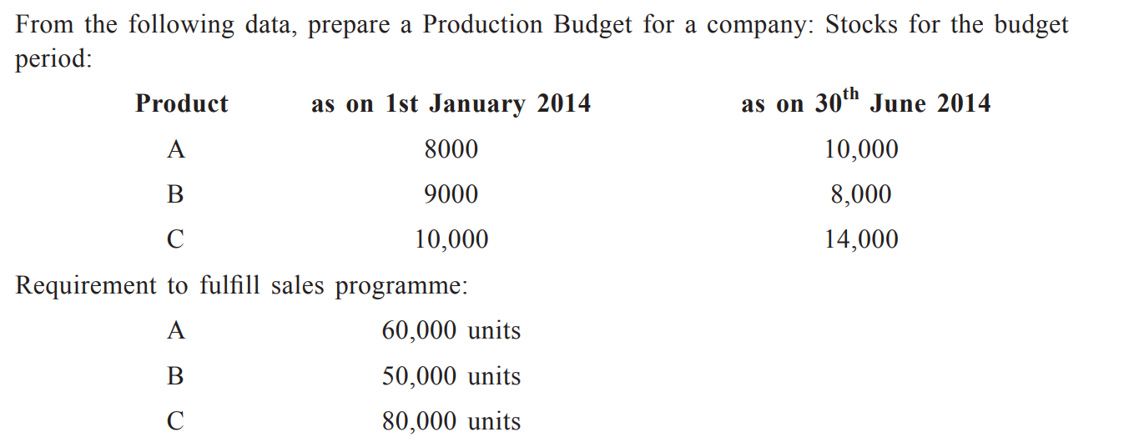  Show working of all the calculations | 10
Q3. |  | 10
  A company sells 6000 units of a product in home market at Rs 20 per unit.
  The marginal cost of production is Rs 15 per unit, and the fixed costs are Rs 10000
  Company wants to sell another 5000 units in the foreign market at Rs 16 per unit,
  with an additional cost of Re 2 per unit to export. Fixed costs are exact. Advice the company, whether it should try to sell in the foreign market or not. If you advise to accept a special order, justify with other non-financial benefits as well.
Q4. |  | 10
  The sales turnover and profit of Krishna Ltd for two years were as follows
  Year | Sales (Rs) | Profit(Rs)
  2020 | 140000 | 18000
  2021 | 160000 | 20000
  You are required to calculate
  i)PV Ratio
  ii)Sales required to earn a profit of Rs 41000
  iii) Profit when sales are Rs 110000
Q5. | Explain the steps in the ABC method and write in brief why it is superior to the conventional costing method | 10
Q6. | “Hope” Hospital is suffering from losses that affect its operations; in this background, help them by applying the “Target Costing” concept to revise the situation. | 10
Q7. | Explain the difference between internal and external failure costs under the “Cost of Quality” concept used in the healthcare industry with suitable examples. | 10

