
Trimester: Sep-Dec 2024
Examination: End Term Examination
Programme code: 08  Programme: MBA EXEC |  | Class: FY |  | Trimester: I  (SVU 2024)
Name of the Constituent College:  K. J. Somaiya Institute of Management |  |  | Name of the department/Section/Center:  Economics
Course Code: 317P08C102 | Name of the Course: ECONOMIC INDICATORS AND MANAGERIAL ECONOMICS

Maximum Marks: 50 Date: 17-12-2024
Notes:
- Answer any 3 questions from Part A and 2 questions from Part B.
- All carry equal marks (10 each)

Question No. | PART A (ANY 3) | Max.  Marks
Q1 | Case let: US data  Business Cycle indicators help the Central Bank to take interest rate policy actions. Using above data and discuss the role of GDP growth, Inflation and Unemployment in analyzing the stages of business cycles. | 10
  Year | GDP Growth | Unemployment Rate | Inflation | GDP change % | Fed fund rate
  2009 | -2.80% | 9.90% | 2.70% | -2.72% | 0.05%
  2010 | 2.50% | 9.30% | 1.50% | 5.31% | 0.13%
  2011 | 1.60% | 8.50% | 3.00% | -1.16% | 0.04%
  2012 | 2.20% | 7.80% | 1.70% | 0.73% | 0.09%
  2013 | 1.70% | 6.70% | 1.50% | -0.44% | 0.07%
  2014 | 2.60% | 5.60% | 0.80% | 0.45% | 0.06%
  2015 | 2.90% | 5.00% | 0.70% | 0.42% | 0.20%
  2016 | 1.50% | 4.70% | 2.10% | -1.04% | 0.55%
  2017 | 2.30% | 4.10% | 2.10% | 0.59% | 1.33%
  2018 | 2.40% | 4.00% | 1.79% | 0.66% | 2.40%
  2019 | 1.80% | 3.60% | 2.16% | -0.63% | 1.55%
  2020 | 1.22% | 8.50% | 0.41% | -5.69% | 0.09%
Q 2 | 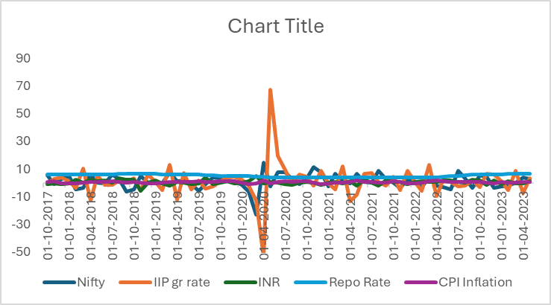  Explain the role of Economic indicators on the financial markets performance (Nifty) using the above graph. | 10
Q3 | Explain the importance of Exchange rates on any Business performance of IT and exporting SMEs. | 10
  Exchange Rates of Indian Rupee
  Date | INR | EUR | YEN
  30-06-2021 | 74.33 | 88.39 | 0.67
  30-07-2021 | 74.42 | 88.54 | 0.68
  31-08-2021 | 73.01 | 86.33 | 0.66
  30-09-2021 | 74.24 | 86.10 | 0.66
  29-10-2021 | 74.88 | 87.28 | 0.66
  30-Nov-21 | 75.17 | 85.41 | 0.67
  31-Dec-21 | 74.34 | 84.21 | 0.65
  31-Jan-22 | 74.62 | 83.40 | 0.65
  28-Feb-22 | 75.34 | 84.23 | 0.65
  31-Mar-22 | 75.79 | 84.20 | 0.62
  29-Apr-22 | 76.43 | 80.86 | 0.59
  31-May-22 | 77.64 | 83.25 | 0.60
  30-Jun-22 | 78.97 | 82.36 | 0.58
  29-Jul-22 | 79.27 | 80.89 | 0.59
  31-Aug-22 | 79.46 | 79.72 | 0.57
  30-Sep-22 | 81.35 | 79.72 | 0.56
  31-Oct-22 | 82.79 | 82.35 | 0.56
  30-Nov-22 | 81.43 | 84.36 | 0.59
  30-Dec-22 | 82.74 | 88.15 | 0.63
  31-Jan-23 | 81.92 | 88.73 | 0.63
  28-Feb-23 | 82.67 | 87.67 | 0.61
  31-Mar-23 | 82.18 | 89.47 | 0.62
  28-Apr-23 | 81.83 | 89.91 | 0.60
  31-May-23 | 82.73 | 88.31 | 0.59
  30-Jun-23 | 82.04 | 88.99 | 0.57
  Source: Database on Indian Economy RBI
Q4 | 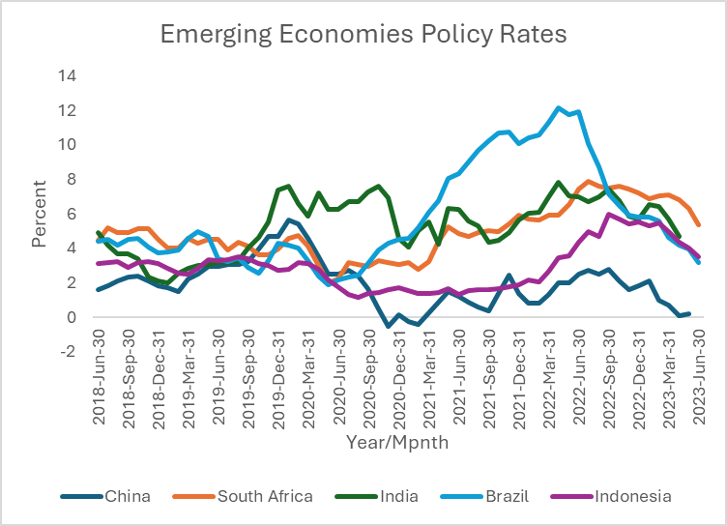  Discuss impact of policy interest rates any two economies mentioned in the above graph for business decisions. | 10
 | PART B (ANY TWO)
The manager’s role is to understand the business in terms of what to produce, for whom to produce and how much to produce. Goods and services that are produced to be priced and sold in different markets. Understanding demand and supply conditions, market structures, are important for pricing decisions.
Answer any two of the following questions
Q5 | Elucidate the role of managers in output and pricing decisions of Oligopoly market. You can take suitable examples to elaborate your answer. | 10
Q6 | Discuss on how to analyze consumer behavior and targeting the products and services to high-, middle- and low-income households taking suitable examples | 10
Q7 | What are the insights one can get from a typical industry report that will be useful for making managerial decisions on marketing, pricing and forecasting? | 10

