
Sem: October-2025
Maximum Marks: 50 Examination: End Exam Date: 11/10/2025 Duration: 2.5 hrs
Programme code: 18  Programme: MBA for Working Executive | Class: FY | Semester: I-  Batch-5- 2025-26
College: K. J. Somaiya Institute of Management | Name of the department/Section/Center:
Course Code: 317P18C106 | Name of the Course: HRM
Instructions:
- Q1 is compulsory
- Answer any 3 Questions from Q2 to Q5
- State your assumptions if any

Question No. |  | Max.  Marks
Q1 | Short Notes (Any one)  - Significance and Process of HR Planning  - Total Rewards | 5 marks
Q2 | Google takes a scientific, evidence-based approach to its selection. The main elements in selection process include work samples, testing, and interviewing. Virtually all of Google’s technical hires take work simulation, such as actually writing algorithms. Work simulations are combined with testing of cognitive ability (similar to IQ tests), and of conscientiousness. Early in its evolution Google put candidates through a dozen or more interviews. However, Google’s analysis showed that after the first four interviews the amount of useful information it got was small. It therefore now generally makes hiring decisions after the fourth interview.  The interviews emphasize situational and behavioural questions. For specific questions, Google provides its interviewers with its QDroid system; this e-mails each interviewer specific questions to ask the candidate for the specific job. Google interviewers were once known for trick questions, but the emphasis now is on using validated questions (from the QDroid system). The questions aim to assess the candidate’s cognitive ability, leadership (particularly willingness to lead projects), “Googleyness” (values such as fun-loving and conscientious), and role-related knowledge (such as in computer science).  Unilever makes use of a four-step process:  1. Candidates complete a short online form with their LinkedIn profile.  2. Candidates spend 20-30 minutes playing game: Unilever developed 13 games that rate candidates’ problem solving, communication, and emotional competencies. Rather than hide the results of this data, each candidate receives customised feedback on how they performed.  3. Candidates take a video interview: By partnering with HireVue, Unilever can digitally assess and rank each candidate with an AI-powered model built around the responses of its known top performers - predicting candidate fit and success with high accuracy. They have a mechanism to internally validate the results.  4. Candidates are invited to Unilever’s Discovery Centre: Candidates simulate and participate in activities they would be expected to perform on a daily basis.  At Southwest, for example, we talk about hiring not for skills but three attributes: a warrior spirit (that is, a desire to excel, act with courage, persevere and innovate); a servant’s heart (the ability to put others first, treat everyone with respect and proactively serve customers); and a fun-loving attitude (passion, joy and an aversion to taking oneself too seriously.)  We’ve found that it’s important to clearly define these expectations — they’re listed on every job description — and build our interviewing methodology around them. The mentality isn’t “We’ll know it when we see it.” It’s “Does this person already live the way we do?” We use behavioural interview questions to determine whether candidates have those key attributes.  Obviously, certain positions require specific skillsets. We’re not going to hire a pilot who has a great attitude but can’t fly a plane! But, if it comes down to two equally qualified candidates, the one with Southwest values will receive the offer. And, more importantly, when we’re faced with a qualified candidate who doesn’t have the right values, we won’t make an offer — no matter how long the job has gone unfilled.  Sources:  Gary Dessler, Human Resources Management, 16th edition, Pearson, 2020  https://www.hirevue.com/blog/hiring/how-unilever-hires-50-of-the-candidates-it-screens  Weber, J. (2015). How Southwest Airlines Hires Such Dedicated People, HBR.  - What is the difference between recruitment and selection? – 5 marks  - Compare and contrast the selection process used at Google, Unilever and Southwest. Which criteria in your opinion should have greater weightage in selection of a candidate: interviews (face-to-face or AI-powered video interview), psychometric tests (like personality, cognitive ability), values fitment, games and work simulations? Justify your answer? – 10 marks | 15 marks
Q3 | In a unique study on decoding global talent, BCG reported the following top 8 factors that contributed to happiness on the job for over 2 lac respondents across the globe:  Happiness on the Job: Top 8 factors  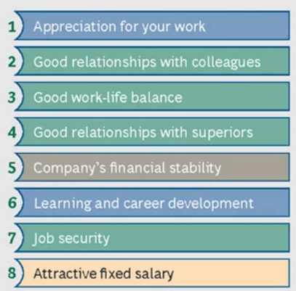  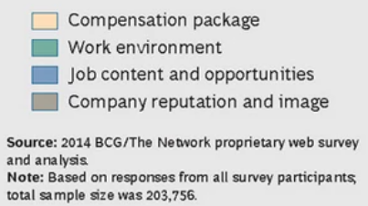  - What is the role of Line Manager, HR and Senior Leadership in positively influencing these eight factors? Explain with examples – 7 marks  - Identify any 2 HR practices/ processes that may impact these eight factors positively or negatively? Justify and state your assumptions (if any) – 8 marks | 15 marks
Q4 | Empower Airways: Bridging the Gap in Line Management Training  Empower Airways, a leading domestic carrier in India, has recently promoted a cohort of young professionals, including Rahul Verma and Kritika Nair, to line management roles in customer service, ground operations, and flight coordination. While they bring fresh energy and technical expertise, their transition has not been without challenges.  During a recent operational disruption at a major airport, decision-making bottlenecks, inefficient resource allocation, and hesitation in real-time problem-solving exposed critical gaps in managerial preparedness. Traditional classroom-based training, which has been the airline’s primary approach, is proving inadequate—described by many as disengaging and disconnected from the fast-paced realities of aviation management.  Recognizing the need for a more dynamic and hands-on learning approach, Empower Airways is rethinking its Learning & Development (L&D) framework. The focus is now shifting towards experiential learning and skill application, ensuring that managers like Rahul and Kritika can confidently navigate high-pressure situations and cross-functional coordination—all within the unique complexities of the aviation industry.  Next Steps: The airline is now seeking answers to the following questions that align with its vision of continuous improvement and adaptability.  - Which training methods will best equip these young managers for their evolving roles, ensuring that the new approach is both engaging and effective? – 7 Marks  - How can Empower Airways measure whether these new approaches are making a real impact on the ground? – 8 Marks | 15 marks
 | Kiran and Charu founded LearnInMotion.com with the mission “to provide work related learning when, where, and how you need it.” They hired salespeople, two programmers, a web designer, and several content management experts to transform the incoming material into content based on the customers’ needs. Kiran and Charu disagree over the importance of having a performance management system. Charu says it’s quite clear whether any particular employee is doing his or her job. It’s obvious, for instance, if the salespeople are selling, and if the Web designer is designing. Charu’s position, like that of many small-business managers, is that “we have 1,000 higher-priority things to attend to” such as boosting sales, attending to customers’ needs and creating the calendar. And in any case, Charu thinks, the employees already get plenty of day-to-day feedback from Charu or Kiran regarding what they’re doing right and what they’re doing wrong. This informal feedback notwithstanding, Kiran believes that a more formal performance management system is essential to sustain performance. “May be this is one reason we’re not getting enough sales and higher customer satisfaction,” Kiran says. They have been debating this for some time now. You are an experienced manager in the company, and they have called you for a meeting to seek your views on what to do.  - Who do you feel is right? Charu or Kiran? Justify your answer – 5 Marks  - Develop a performance management system for LearnInMotion. Share compelling arguments to gain buy-in of both Charu and Kiran – 10 Marks | 15 marks

