
Trim: Jul 2025 - Sep 2025
Maximum Marks: 50 Examination: ETE Exam Date:26/09/2025 Duration: 3 Hrs.
Programme code: 08  Programme: MBA Executive | Class: SY | Semester: IV
College: K. J. Somaiya Institute of Management | Name of the department/Section/Center:  Operations
Course Code: 317P08C405 | Name of the Course: Project Management
Instructions:
- Attempt any 5 questions.
- Make suitable assumptions wherever applicable.

Question  No. |  | Max  Marks
Q1. | XYZ Tech, a mid-sized software development company, secured a contract to develop a customized project management tool for a client. The project had an initial timeline of six months, a budget of INR 500,000, and a defined scope, including essential features like task tracking, collaboration tools, and analytics.  Three months into the project, the client requested additional features, such as AI-driven project recommendations and enhanced security layers. The project team was faced with a dilemma: accommodating the new scope without exceeding the budget or delaying the deadline.  The team considered extending the project timeline by three months to integrate the new features without increasing costs. However, the client needed the tool on schedule. Hiring additional developers would allow the team to meet the deadline while incorporating the new features, but this would push the budget beyond INR 650,000, which the client was reluctant to approve. To stay within budget and on time, the team could reduce testing and quality assurance efforts, but this risked delivering a product with potential defects.  After discussions, XYZ Tech and the client agreed to a phased rollout approach. The team would deliver the core product on time and within budget while developing the advanced features in a second phase, funded separately.  - If you were the project manager, how would you prioritise cost, time, and scope in this scenario?  - What is scope creep? What strategies can organisations use to manage scope creep effectively in project management? | 10
Q2. | Based on the information, answer the following questions:  - Draw the Network diagram in AOA/AON style. Identify the critical path and the slack for the various activities. What is the normal cost and time of the project?  - Which activities would you shorten to cut two days from the schedule in a rational fashion? What would be the incremental cost? Is the critical path changed? | 10
  Activity | Predecessor | Normal Time (Days) | Crash Time (Days) | Normal Cost | Crash Cost
  A | - | 7 | 6 | 7,000 | 8,000
  B | A | 2 | 1 | 5,000 | 7,000
  C | A | 4 | 3 | 9,000 | 10,200
  D | B, C | 5 | 4 | 3,000 | 4,500
  E | D | 2 | 1 | 2,000 | 3,000
  F | D | 4 | 2 | 4,000 | 7,000
  G | E, F | 5 | 4 | 5,000 | 8,000
Q3. | Based on the information below, answer the following questions:  - Determine the expected completion time and variance for each activity, and the critical path for the project.  - What is the probability that Kelle Carpet and Trim will finish the project in 40 days or less? | 10
  Activity | a | m | b | Immediate Predecessor(s)
  A | 3 | 6 | 8 | —
  B | 2 | 4 | 4 | —
  C | 1 | 2 | 3 | —
  D | 6 | 7 | 8 | C
  E | 2 | 4 | 6 | B, D
  F | 6 | 10 | 14 | A, E
  G | 1 | 2 | 4 | A, E
  H | 3 | 6 | 9 | F
  I | 10 | 11 | 12 | G
  J | 14 | 16 | 20 | C
  K | 2 | 8 | 10 | H, I
Q4 | - Critically highlight the difference between PERT and CPM.  - Differentiate between projects and routine activities. What is project management? | 10
Q5. | A construction company has undertaken a small infrastructure project that involves multiple tasks (A to G). The company has a limited labor workforce and can allocate a maximum of nine laborers per day due to budget constraints and workforce availability. However, if the current project schedule is followed, there are certain days when labor demand exceeds the available workforce. The project manager must reschedule activities strategically to ensure that no more than nine laborers are working on any given day while keeping the project on track. Allocate the required resources, then level them so that the subcontractor does not use more than nine laborers at any time. | 10
  Activity | Duration (Days) | Immediate Predecessor(s) (IPA) | Labor Requirement
  A | 3 | - | 4
  B | 5 | A | 3
  C | 4 | A | 5
  D | 8 | A | 2
  E | 6 | B | 4
  F | 5 | B, C | 3
  G | 4 | D, E, F | 5
Q6. | A project consisting of eight activities was reviewed at the completion 14 days after its start. Using the concept of earned value, find out the following at the end of the 14th day.  i. Schedule variance  ii. Cost variance  iii. Schedule performance index (SPI)  iv. Cost performance index (CPI)  v. Expected time to complete (ETC)  vi. Expected cost at completion (EAC)  What is your subjective analysis of the project performance based on SPI and CPI?  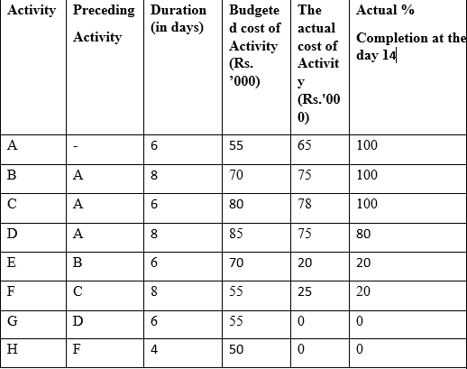 | 10
Q7. | - A company is evaluating a project with the following details:  Initial Investment: ₹8,00,000  Annual Cash Flows: ₹2,50,000 for 5 years  Discount Rate: 10%  Calculate the Net Present Value (NPV) of the project. Determine the Profitability Index (PI). Should the project be accepted?  - Explain the risk management process in project management. | 10

