Question No. |  | Max.  Marks
Q1. | - Refer to “Patient Age Distribution Histogram.” | (3)CO3  (3)CO5  (2)CO5  (2)CO2
  - Explain what a histogram shows and why it is important in healthcare analytics.  - Interpret the pattern (high frequency age 0–5, peaks at 35–45, decline after 60).  - Recommend two managerial decisions based on the insights.  - Write code to add title “Patient Age Distribution” to the graph. | 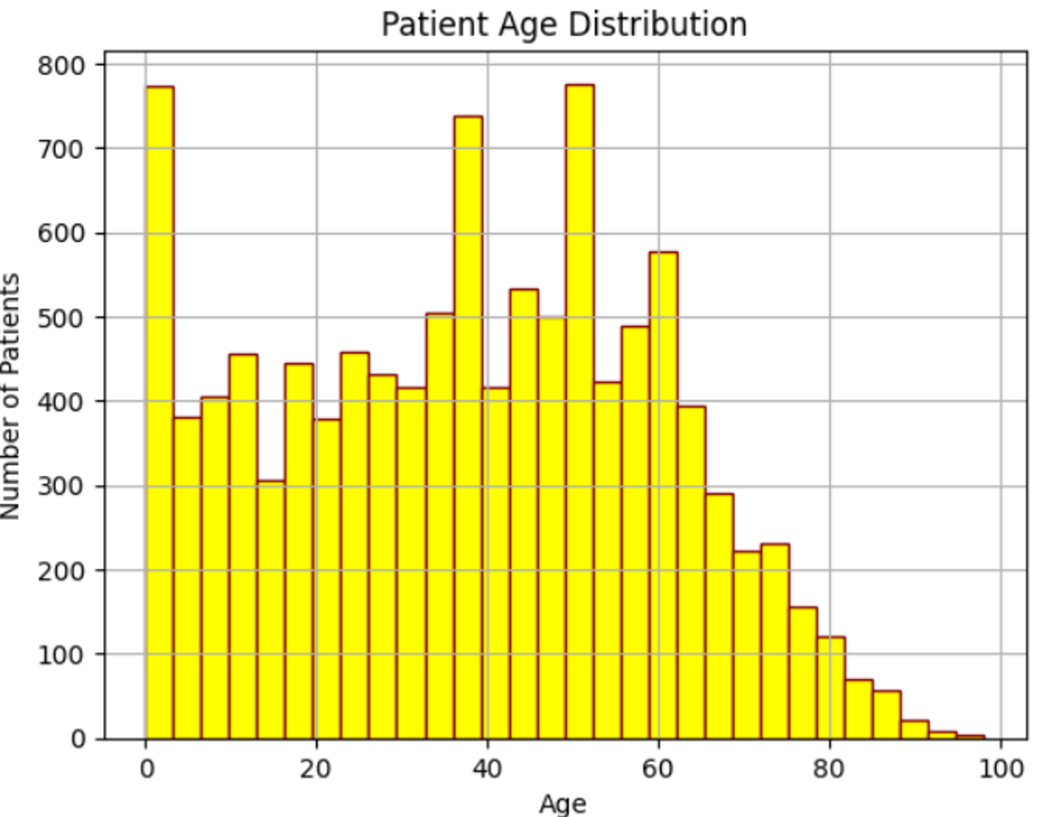
 | - Consider the following Dataset and write Python code - | (10)CO2
  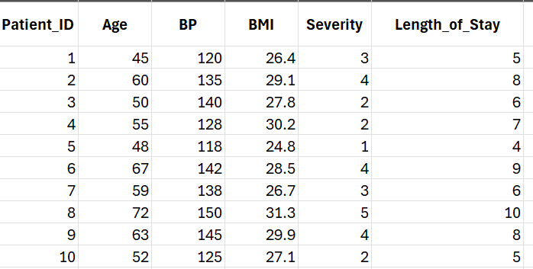 | a. to show first 4 and last 3 rows data.  b. to show the detailed information of the dataset.  c. to display statistical details of the data.  d. to read this dataset.  e. to display the count of null values in each column.
Q2. |  | (3)CO1  (3)CO4  (2)CO4  (2)CO2
  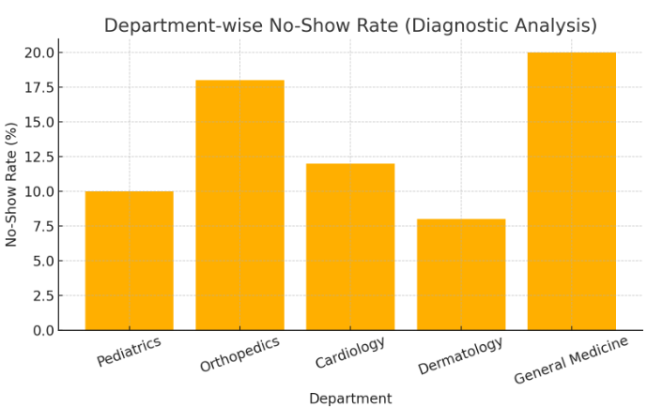 | - Differentiate between Descriptive Analytics and Diagnostic Analytics with one example from hospital operations.  - Suppose you observe a rising number of appointment “no-shows.” How would you use diagnostic analytics to find the root cause?  - How can such findings support evidence-based decision-making?  - Write code to add labels to X and Y axis to the graph.
Q3. | A heatmap of hospital data shows a strong positive correlation (+0.85) between hospital stay length and treatment cost, and a negative correlation (–0.60) between BMI and physical activity level.  - Interpret both these findings in simple terms.  - What managerial insights can be drawn from such correlation analysis?  - Why should healthcare managers understand correlation before making policy or financial decisions? | (3)CO3  (3)CO3  (4)CO5
Q4. | You are given the following Python code used for analyzing patient appointment data:  import pandas as pd  df = pd.read_csv("/content/Appointment_No_Show.csv")  print(df['No-show'].value_counts())  - What is this code doing in simple terms?  - What type of analytics does this represent — Descriptive, Diagnostic, Predictive, or Prescriptive, write it’s significance as well?  - If the output shows: | (3)CO3  (3)CO5  (4)CO5
  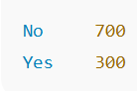 | How would you interpret this result as a healthcare manager?
Q5. | A hospital in Chennai was losing patients to competitors. They assumed it was because of high cost — but data told a different story. Regression analysis showed that waiting time and staff courtesy mattered far more than cost. Within six months of improving those two factors, patient satisfaction jumped 40%. | (3)CO3  (3)CO5  (4)CO5
  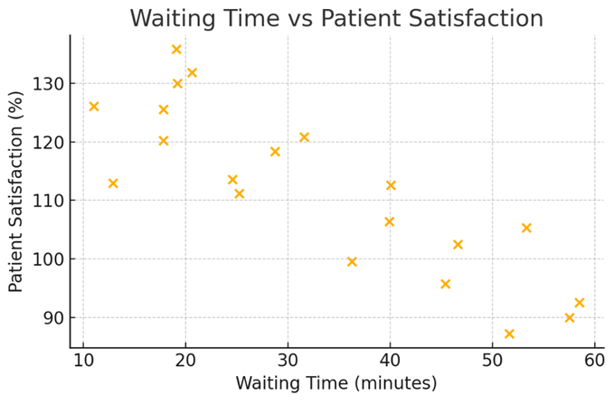 | - What kind of correlation do you observe in each plot?  - Which factor appears to have a stronger influence on patient satisfaction?  - How can hospital managers use these insights for decision-making?

