
Semester: June - Oct 2025
Maximum Marks: 50 Examination: ETE Exam Date:29-10-2025 Duration: 2 hours
Programme code: 01  Programme: MBA Finance (Batch 2024-26) | Class: SY | Semester: III
College: K. J. Somaiya Institute of Management | Name of the department: Finance & Law
Course Code: 17P2282 | Name of the Course: Mergers & Acquisitions
Instructions:
- Attempt any 5 questions out of 6. Ensure that total attempt is 50 Marks.
- Usage of pencil is restricted to rough work and drawing tables and diagrams only. Answers written or cancelled using pencil shall invoke negative marking.
- New question is to be answered on a new page.
- Answer using only blue or black ball point pen. Usage of any other color or markers is disallowed.

Question No. |  | Max.  Marks | CO
Q.1 (A)  Q.1 (B) | Godrej and Sara Lee Corporation had a joint venture which was catering to the home care market segment in India before Sara Lee Corporation exited the venture. What are the typical features of a joint venture? What is the reason of formation of such ventures in India? What was the uniqueness of the Hutchinson Essar joint venture in India? What kind of legal complications did it lead to when Vodafone bought stake from Hutch?  What are the typical features of a Merger and Acquisition? How do the two differ from each other? Explain with examples of your choice. | 05  05 | CO1  CO1
Q.2 | What is the legal procedure adopted for carrying out mergers in India? What regulations and regulatory authorities need to be catered to? | 10 | CO3
Q.3 | Companies X & Y have the following features:  X and Y are competitors in the same market selling similar products. Y is the subsidiary of a larger conglomerate. Basis this information, answer the following questions:  - Evaluate the above financials and comment as to what problems is company X likely to face from Company Y?  - What remedies does Company X have to eliminate these problems?  3. Applying the concept of synergies, how does a merger help in case  Company X decides to absorb company Y? What kind of  synergies is the combined entity likely to gain? | 10 | CO2
   | X | Y
  Selling Price per unit (Rs.) | 350 | 350
  Variable Cost per unit (Rs.) | 200 | 200
  Total Fixed costs (Rs.) | 1,00,000 | 1,00,000
  Installed Capacity (Units) | 1,000 | 1,000
  Operating capacity | 70% | 20%
Q.4 | Select a sector / industry / company of your choice. If you were an investment banker or consultant, what kind of questions are you likely to ask to your client while carrying out due diligence? Kindly classify similar questions that you will ask under suitable headings. | 10 | CO3
Q.5 | What do you mean by synergy? With suitable examples, explain the concept of synergy. | 10 | CO2
Q.6 | Refer to the Football Field diagram given below:  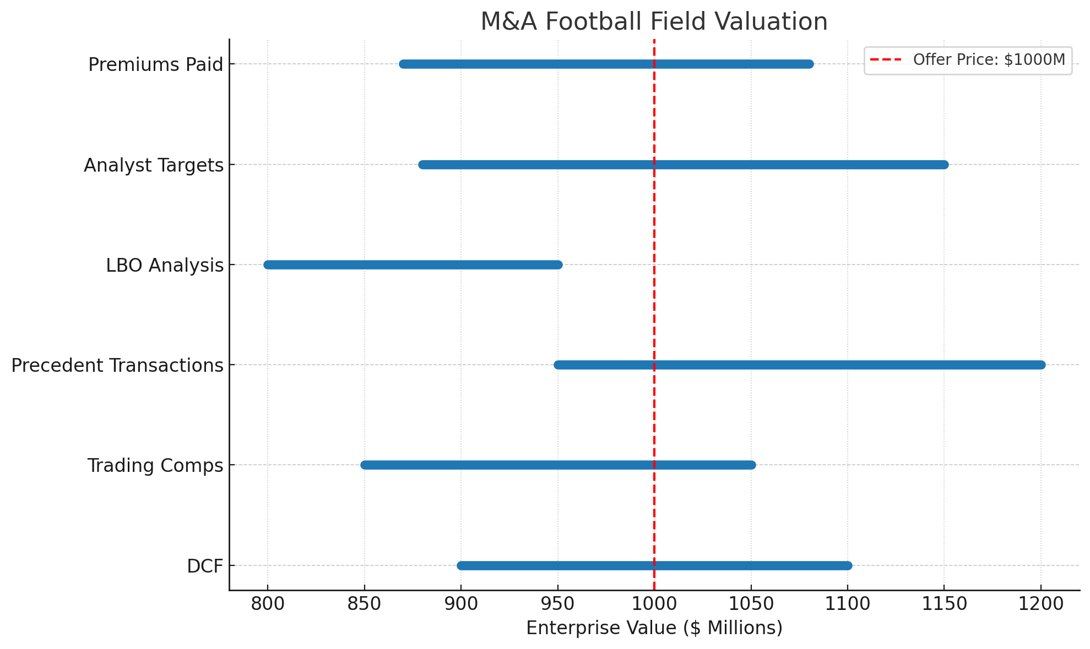  Given the offer price of the deal to be around $1,000 M, analyze the offer price wrt the various benchmarking options available in the diagram and arrive at a conclusion regarding the overall deal valuation vis-à-vis its pricing. How does this tool prove to be useful in deal negotiations? | 10 | CO2, CO4

