
Semester: III-April 2025
Maximum Marks: 25 Examination: End Sem Exam Date: 21/04/2025
Duration:1.5hrs
Program code: 19  Program- PGDM-Executive | Class: FY | Semester: III  Batch-1 (OPS&SCM)
College: K. J. Somaiya Institute of Management | Name of the department/Section/Center: Operations Management
Course Code: 117I19C302 | Name of the Course: Supply Chain Analytics
Instructions:
a) Questions 1,2,3 are compulsory. Questions 4 and 5: Answer any 1 question.
b) Wherever applicable, the formula and calculations should be clearly shown.
c) Softcopy of Excel output file is not to be submitted.
d) Wherever Excel is used, the Excel output should be tabulated/ written/ plotted (as applicable) in your answer sheet.
e) Only Step wise answering will earn marks. Writing the direct answer without any calculations or Excel output would be considered as copying and shall be marked zero.

Question No. |  | Max.  Marks
Q1 | The owner of a PC company is thinking of adding a new assembly line which will require leasing new equipment for a monthly payment of $50,000. Variable costs would be $25 per PC and the PC would retail for $500 each.  a) How many PCs must be sold to Break even?  b) What would be the Profit/loss if 100 PCs are assembled and sold in a month?  c) What would be the Profit/loss if 200 PCs are assembled and sold in a month?  d) How many PCs must be sold to realise a profit of $5000?  e) If 250 PCs can be sold, and profit target is $5000, what price should be charged per PC? | 7
Q2 | A mobile repair service has a design capacity of 180 repairs/day. Its effective capacity is 164 repairs/day and its actual output is 160 repairs/day. Compute the Efficiency and Utilization. | 3
Q3 | Determine the coordinates of the Centre of Gravity for the below problem. Indicate the solution using a scatter plot in Excel.  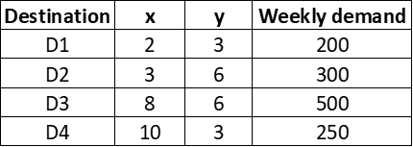 | 5
Q4 | Fixed and variable costs for four potential plant locations are shown below:  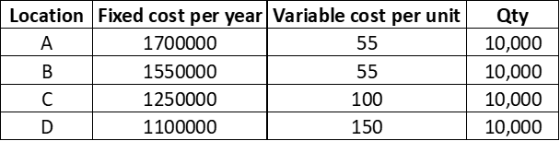  - Tabulate the total cost for the four locations by varying the quantity 0, 1000, 2000, …, 15,000 in Excel. Plot the Total cost Vs Quantity for these locations on a single graph in Excel.  - Find the Fixed cost and Variable cost for 10,000 units.  - Identify the quantity range for which each location alternative is superior with the help of the Total cost table and the graph.  - If the expected output at the selected location is 7000 units per year, which location would provide the lowest total cost?  - For what quantity range does Location A provide the lowest total cost? | 10
Q5 | Daily sales data for a college canteen is tabulated for 14 periods. The canteen manager believes that the data shows seasonality as well as trend. He wants your help in forecasting the sales for period 15 to 21.  - Plot the given data in Excel. Does the data show seasonality?  - Calculate the seasonal relatives (Monday to Sunday).  - De-seasonalise the data, plot the data in Excel sheet and find the trend line equation. Does the data show any trend – upward or downward?  - Forecast the sales for periods 15 to 21, incorporate seasonality to the forecast and find the sales.  - Plot the entire data for period 1 to 21 in Excel.  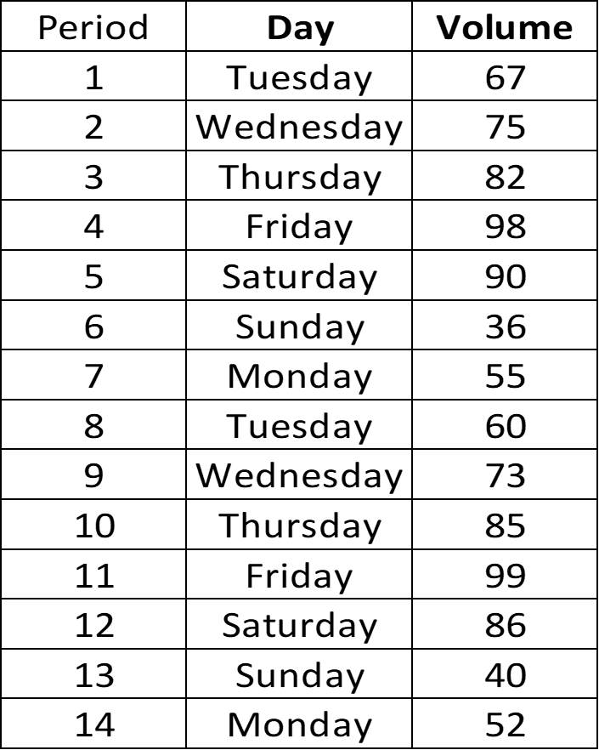 | 10

