
Semester: III-April 2025
Maximum Marks: 25 Examination: End Sem Exam Date: 22nd April 2025
Duration:1.5hrs
Program code: 19  Program- PGDM-Executive | Class: FY | Semester: III  Batch-1 (OPS&SCM)
College: K. J. Somaiya Institute of Management | Name of the department/Section/Center: Operations
Course Code: 117I19C304 | Name of the Course: Service Operations
Instructions:
- Question 1 is compulsory.

Question No. |  | Max.  Marks
Q1. | The rise of platform-based services has, arguably, made it easier to track customers’ behaviour, and take action when necessary. The type of passenger who consistently leaves their litter in taxis, pressurises drivers into breaking speed limits, or is bad-mannered and rude towards drivers, could potentially be banned from using that taxi service for life. This was confirmed when Uber, the world’s biggest ride-hailing company, declared that it will ban passengers in some of its markets if they are rated as appreciably below average by its drivers. After every ride, Uber drivers rate passengers, using a rating system that awards between one and five stars.  Similarly, passengers can also rate the driver. Passengers can find out their average score by viewing their ratings on the Uber app. As it announced the policy, Uber did not say how bad a customer’s score would need to be before he or she was banned. Uber explained its justification for the policy as being based on mutual respect. Drivers are expected to meet a minimum rating standard (which varies from city to city), so passengers should also be held accountable for their behaviour. Drivers with persistently bad ratings can, eventually, be removed by the company, so bad customers should expect the same fate. However, Uber did make clear that they expected only a small number of customers to be impacted by ratings-based ‘deactivations’. Moreover, customers on a low rating would have plenty of warning when they were getting close to being banned. They would also be given tips on how to improve their scores. For example, these might include being courteous to drivers, not leaving litter in the vehicle, putting on their seat belt and being ready on time.  - How does Uber’s customer rating system contribute to service quality management?  - What do you think are the problems of platform services such as this rating both providers and users of a service? | 07  08
Q2. | Comment on the below-mentioned figure. Please suggest a suitable example for each quadrant.  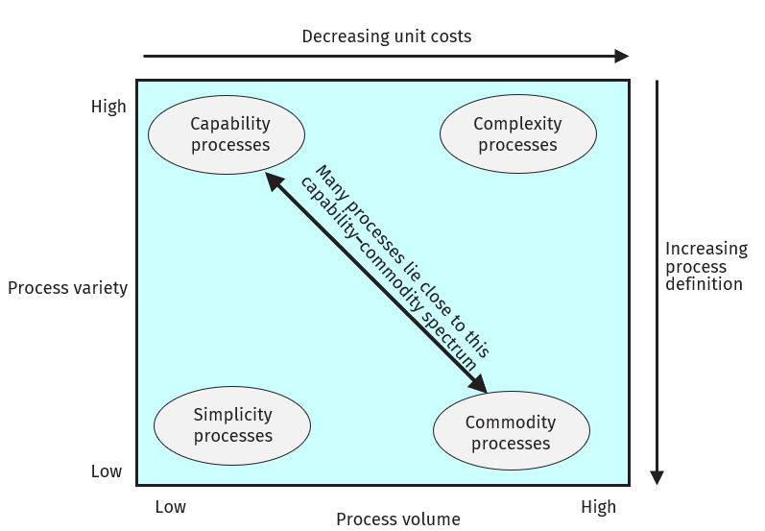 | 10
OR
Q3. | Write a short note on ANY TWO:  - Coping zone  - SERVQUAL  - Service characteristics | 10

