
Sem: Sep-2024
Maximum Marks: 50 Examination: End Exam Date: 25th Sept. 2024 Duration: 90 Minutes
Programme code:17  Programme: PGDM(Executive) (G&B) | Class: FY | Semester: IV  Batch-1
College: K. J. Somaiya Institute of Management | Name of the department/Section/Center: Finance and Law
Course Code: 117I17E408 | Name of the Course: Project Management-II
Instructions:
- Question no. 1 is compulsory
- Solve any ONE from the remaining

Question No. |  | Max.  Marks
1 | A company is considering which of two mutually exclusive projects it should undertake. The finance director thinks that the project with a higher NPV should be chosen, whereas the MD thinks that the one with a higher IRR should be undertaken, especially as both projects have the same initial outlay and length of life. The company anticipated a cost of capital of 10%, and the cash flows of the project are as follows:  - Comment on the NPV and IRR of each project.  - State, with reasons, which project you would recommend.  - Explain the inconsistency in the ranking of the two projects.  - What are the disadvantages of IRR criteria?  - How to resolve the ranking conflict?  - Explain the concept of MIRR.  - What is the payback period? Comment on the payback period of both projects.  - What is BCR? Comment on the BCR of both projects. | 10
  Projects | 0 | 1 | 2 | 3 | 4 | 5 | NPV | IRR | Payback | BCR
  X | -200 | 35 | 80 | 90 | 75 | 20 | 29.20 | 16% | 2.94 Yrs. | 1.14
  Y | -200 | 218 | 10 | 10 | 4 | 3 | 18.55 | 19% | 0.92 Yrs. | 1.09
Q2 | Mint Limited is considering investing in an iron ore mine. The mint will require an initial investment of $1250 million and is expected to have a production capacity of 8 million tons of iron ore. The other details of the investment are provided as follows:  - The initial investment of $1250 million will be depreciated over ten years, using the double-declining rate of 16%, down to a salvage value of $219 million at the end of 10 years.  - Mint Limited borrowed $500 million at its current cost of debt of 4.05% using a ten-year term loan paid off in equal annual installments.  - The mine will start production midway through year 1, producing 4 million tons of iron ore for year 1, with production increasing to 6 million tons in year 2 and 8 million tons after that (until year 10)  - The selling price per unit is currently $100 and is expected to keep pace with inflation for the plant's life.  - The variable cost of production is expected to be $45 per ton, and there is a fixed cost of $125 million in year 1. Both costs will grow at an inflation rate of 2% after that.  - The working capital requirements are estimated to be 20% of total revenue, and the investments must be made at the beginning of each year. At the end of the 10th year, the entire working capital is anticipated to be salvaged.  - A corporate tax rate of 34% will be applied to this project.  - Based on the above information, the net cash flows, NPV, and IRR are estimated as follows:  Based on the above case answer the following questions:  - Should the following be included in Mint Limited cash flows projects? Why or why not?  - R&D Cost incurred before the start of the project.  - Reduction in Mint Limited other products revenue because of this new project.  - Interest costs.  - Depreciation.  - Change in working capital  - Mint limited estimated that the following variables may change by +/-10%, +/-20% & +/- 30%, with this regards Mint Limited wants to know the sensitivity of NPV to those variables, and the output of the same is given below:  Comment on the above output table.  - Mine limited sensitivity spider web is given in the figure as follows:  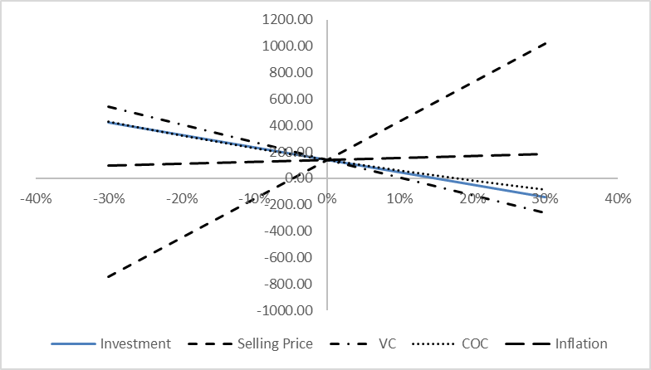  Comment on the sensitivity of the spider web. Which variable causes a major change in NPV?  - Based on scenario analysis done under the best-case and worst-case following output Mint limited extracted:  Comment on the above output  - Explain the concept of NPV-BEP. | 15
  Year | Net cash flows
  0  1  2  3  4  5  6  7  8  9  10 | -1332  93  158  272  269  267  266  266  267  269  689
  NPV  IRR | 138.08  13.10%
  Variation | Investment | Selling Price | VC | COC | Inflation
  -30% | 420.36 | -743.11 | 541.47 | 426.06 | 94.44
  -20% | 326.51 | -449.14 | 407.25 | 322.14 | 109.05
  -10% | 232.66 | -155.16 | 273.03 | 226.67 | 123.84
  0% | 138.81 | 138.81 | 138.81 | 138.81 | 138.81
  10% | 44.96 | 432.78 | 4.59 | 57.84 | 153.96
  20% | -48.90 | 726.75 | -129.63 | -16.89 | 169.31
  30% | -142.75 | 1020.73 | -263.85 | -85.95 | 184.84
  Expected NPV | 560.314627
  SD | 1231.90732
  CV | 2.19859925
  Prob. Of loss | 0.32461396
Q3 (A) | 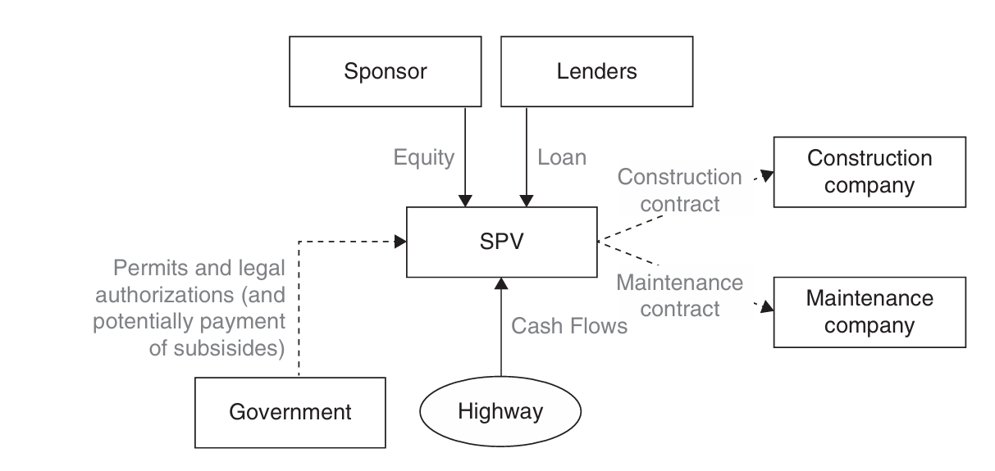  Explain the following project finance structure. What are the various parties involved in project finance structure. | 7
Q3 (B) | Explain the difference between project finance and corporate finance. Explain merits and demerits of project finance. | 8
Q4 (A) | BG Real Estate Speculator, Inc., and the NC Utility company have the following EBIT and debt serving burden:  The tax rate for both companies is 40%. Compute ICR and DSCR for both companies and suggest for which company you feel more comfortable if you were lender? Why? | 7
   | BG | NC Utility
  Expected EBIT  Annual interest  Annual Principal repayment | 5000000  1600000  2000000 | 100000000  45000000  35000000
Q4 (B) | Explain in brief the following concepts:  - Real Estate Investment Trusts (REITs)  - Infrastructure Investment Trusts (InvITs)  - Debt as a source of project financing | 8

